BASKETBALL RULES AND REGULATIONS

Object of the game: The object of the game is to score more points than your opponents by shooting the ball with your hands into the other team’s basket (from top to bottom).

Fouls and Violations

FOULS
Personal fouls: Personal fouls include any type of illegal physical contact.
- Hitting, Pushing, Slapping, Holding.
Personal foul penalties: If a player is fouled while shooting, then he/she gets two free throws if the shot doesn't go in, but only one free throw if the shot does go in.
- Three free throws are awarded if the player is fouled while shooting a three-point goal and they miss their shot. If a player is fouled while shooting a three-point shot and makes it anyway, they are awarded one free throw. Thus, he could score four points on the play.
- Inbounds. If fouled while not shooting, the ball is given to the team the foul was committed upon. They get the ball at the nearest side or baseline, out of bounds, and have 5 seconds to pass the ball onto the court.
Charging. An offensive foul that is committed when a player pushes or runs over a defensive player. The ball is given to the team that the foul was committed upon.
Blocking. Blocking is illegal personal contact resulting from a defender not establishing position in time to prevent an opponent's drive to the basket.
Flagrant foul. Violent contact with an opponent. This includes hitting, kicking, and punching. This type of foul results in free throws plus the offense retaining possession of the ball after the free throws.
Intentional foul. When a player makes physical contact with another player with no reasonable effort to steal the ball. It is a judgment call for the officials.
Technical foul. A player or a coach can commit this type of foul. It does not involve player contact or the ball but is instead about the 'manners' of the game. Foul language, obscenity, obscene gestures, and even arguing can be considered a technical foul, as can technical details regarding filling in the scorebook improperly.

VIOLATIONS
Walking/Traveling. Taking more than 'a step and a half' without dribbling the ball is traveling. Moving your pivot foot once you've stopped dribbling is traveling.
Carrying/palming. When a player dribbles the ball with their hand too far to the side of or, sometimes, even under the ball.
Double Dribble. Dribbling the ball with both hands on the ball at the same time or picking up the dribble and then dribbling again is a double dribble.
Held ball. Occasionally, two or more opposing players will gain possession of the ball at the same time. In order to avoid a prolonged and/or violent tussle, the referee stops the action and awards the ball to one team or the other on a rotating basis. (Jump ball).
Goaltending. If a defensive player interferes with a shot while it's on the way down toward the basket, while it's on the way up toward the basket after having touched the backboard, or while it's in the cylinder above the rim, it's goaltending and the shot counts. If committed by an offensive player, it's a violation and the ball is awarded to the opposing team for a throw-in.
Backcourt violation. Once the offense has brought the ball across the mid-court line, they cannot go back across the line during possession. If they do, the ball is awarded to the other team to pass inbounds.
Time restrictions. A player passing the ball inbounds has five seconds to pass the ball. If they do not, then the ball is awarded to the other team. Other time restrictions include the rule that a player cannot have the ball for more than five seconds when being closely guarded and, in some states and levels, shot-clock restrictions requiring a team to attempt a shot within a given time frame.

Player Positions

Center. Centers are generally your tallest players. They generally are positioned near the basket.
Centers are expected to get rebounds and to keep opponents from shooting by blocking shots and passes.
Forward. Your next tallest players will most likely be your forwards. They can play near the basket or further away as well so that they can either take close shots or drive for goals, and take outside shots.
Guard. These are potentially your shortest players and they should be really good at dribbling fast and passing. It is their job to bring the ball down the court and set up offensive plays. They also need to be able to drive to the basket and to shoot from the perimeter.

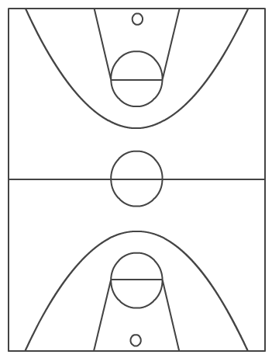
Free Throw Line
Sideline
Three Second Lane
Base Line
Three Point Line
Mid Court Line

