Name:
Striking Tennis Test
- Matching: Label the picture with the correct skill cue.
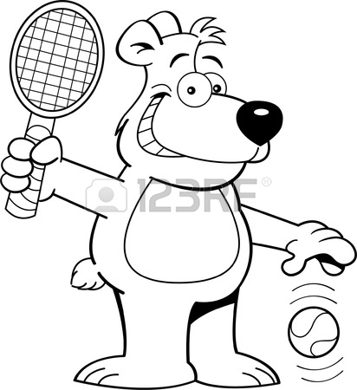
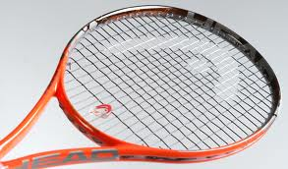
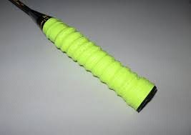
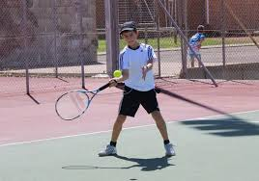

- Label the Tennis Court Parts:

- Short Answer: Please use the back of the paper to answer the question (if needed)

